Environmental Sustainability Metrics:
A Global Analysis of Land, Emissions, Energy, Water, and Biodiversity Trends

Data Analytics Capstone Project
Prepared By — Nwafor Chinaza

AnalystLab Africa
Data Source: World Bank — World Development Indicators (WDI)
Tool: Excel
Power Query
Power BI Desktop
PowerPoint

1. Objective / Problem Statement
Environmental sustainability is one of the most pressing global challenges of the current decade, spanning deforestation, greenhouse gas emissions, the transition to renewable energy, freshwater scarcity, and biodiversity protection. Governments, investors, and development organizations increasingly rely on comparable, cross-country data to identify which regions are most at risk and which policy approaches are producing measurable results.
This project analyzes global Environmental Sustainability Metrics using the World Bank's World Development Indicators (WDI) dataset, covering 217 countries and 23 environment-related indicators across five pillars: land use, emissions, energy, water, and biodiversity. The objective is to apply a complete data analytics workflow from raw data acquisition through cleaning, transformation, analysis, and interactive visualization to answer three core questions:
- Which countries and regions are furthest along in environmental decline, and what does that decline look like across land, emissions, and water metrics?
- Which countries are demonstrating measurable environmental progress, and what distinguishes them from those still declining?
- What actionable recommendations can be drawn from these patterns for policymakers, investors, and development organizations such as AnalystLab Africa's partner network?
The final deliverable is a two-page interactive Power BI dashboard structured around a "Challenge" narrative and a "Bright Spots" narrative supported by this report, a public GitHub repository, and a recorded walkthrough video.

1.1 Project Process Overview
This project follows the standard six-phase data analytics process Ask, Prepare, Process, Analyze, Share, Act to ensure the workflow is traceable from problem definition through to actionable recommendations. Each phase maps directly onto the report sections required by the capstone brief, shown below.
Phase | Report Section | What Was Done
Ask | Section 1 — Objective / Problem Statement | Defined the three core questions this analysis answers.
Prepare | Section 2 — Dataset Description | Sourced and evaluated the WDI dataset; selected 23 relevant indicators.
Process | Section 3 — Data Cleaning Process | Cleaned, unpivoted, and merged the data; documented every transformation.
Analyze | Section 4 — Analysis Methodology | Built DAX measures and Top N comparisons to surface patterns.
Share | Sections 5 & 6 — Key Findings / Insights + Power BI Dashboard | Communicated results through KPIs, charts, and narrative insight.
Act | Section 7 — Recommendations | Translated findings into specific, targeted actions for stakeholders.

2. Dataset Description
The World Development Indicators (WDI) is the World Bank's flagship collection of global development statistics, covering over 200 countries and territories across nine themes including Economy, Poverty, Education, Health, Environment, Infrastructure, Trade, Technology, and Governance. The dataset was downloaded as a bulk CSV package (WDI_CSV.zip) from the official World Bank Data Topics portal.

2.1 Files Provided vs. Files Used
The WDI bulk download contains six files. This analysis deliberately evaluated all six and selected the two that were structurally necessary for the dashboard's core analysis:
Indicator | Value | Aggregation
WDICSV.csv | Used — primary dataset | Indicator values by country, indicator, and year (1960–2025)
WDICountry.csv | Used — enrichment | Region and Income Group classification per country, used for segmentation and slicers
WDISeries.csv | Reviewed, not loaded | Indicator metadata (definitions, units) — used for reference during indicator selection
WDIfootnote.csv | Reviewed, not loaded | Country-specific data caveats; outside the scope of a dashboard-level analysis
WDIcountry-series.csv | Reviewed, not loaded | Coverage map of which indicators exist per country; redundant given the primary file only contains real values
WDIseries-time.csv | Reviewed, not loaded | Notes on indicator definition changes over time; not relevant to the indicators selected

2.2 Indicator Selection
From the full WDI indicator catalogue, 23 environment-related indicators were selected, spanning five analytical pillars to ensure the dashboard tells a complete sustainability story rather than a narrow one:
- Emissions: CO2 and total greenhouse gas emissions, PM2.5 air pollution.
- Energy: Renewable energy consumption, fossil fuel share, electricity access, electricity mix (hydro, coal, non-hydro renewables), energy use per capita.
- Land: Forest area (% and sq. km), agricultural land, protected terrestrial/marine areas, terrestrial protected areas.
- Water: Freshwater withdrawal, water stress level (SDG indicator 6.4.2), renewable freshwater resources per capita.
- Biodiversity: Threatened mammal, bird, and plant species counts.
- Context: Urban population share and population density, used to contextualize development pressure.

3. Data Cleaning Process
All cleaning and transformation was performed in Power Query (Power BI Desktop), following a documented, reproducible sequence of steps. Each step below is recorded exactly as applied, including verified row counts at each stage.

3.1 Structural Preparation
- Loaded WDICSV.csv via Get Data → Text/CSV and promoted the first row to column headers (Country Name, Country Code, Indicator Name, Indicator Code, and 66 year columns from 1960–2025).
- Filtered Indicator Code to the 23 selected environmental indicators, reducing the dataset from approximately 397,000 rows to 6,095 rows (217 countries × up to 23 indicators, prior to removing aggregate regions).

3.2 Standardizing Format : Unpivoting
- Unpivoted the 66 year columns into two columns, Year and Value, converting the table from wide format (one column per year) to long format (one row per country–indicator–year combination). This produced 402,270 rows.
- Set correct data types: Year as Whole Number and Value as Decimal Number. Data types were deliberately applied after unpivoting, not before, to avoid Power Query mis-inferring types from unpromoted headers.

3.3 Handling Missing Values
Many WDI indicators are not reported annually for every country some indicators (for example, survey-based social indicators) are only updated every three to five years, and most environmental indicators have minimal or no coverage prior to 1990. Rather than fabricate values (e.g., filling gaps with zero, which would misrepresent "no data" as "zero occurrence"), all rows with a blank Value were removed. This reduced the dataset from 402,270 rows to 189,016 rows containing only genuine, recorded observations.

3.4 Correcting Inconsistencies : Removing Regional Aggregates
The WDI file mixes real countries with the World Bank's own pre-calculated regional and income-group aggregates (e.g., "Sub-Saharan Africa", "World", "Low income"), which are not countries and would distort country-level averages if included. WDICountry.csv was loaded separately, limited to Country Code, Region, and Income Group, and filtered to rows with a non-blank Region isolating the 217 genuine countries and territories from the 265 total codes in the reference file. The two tables were joined on Country Code using an Inner Join, which automatically retained only rows belonging to real countries. This step reduced the dataset to its final analytical size of 153,589 rows.

3.5 Duplicate Check
The source file was verified to contain zero duplicate Country + Indicator combinations prior to unpivoting, confirmed programmatically against the raw file. No duplicate removal was required.

3.6 Calculated Columns
Twelve custom DAX measures were created to support trend-based analysis beyond simple averages, described fully in Section 4.2.

3.7 Cleaning Summary
Cleaning Stage | Row Count | Action Applied
Raw rows (23 indicators, all countries/aggregates, wide format) | 6,095 | Filtered to selected indicators
After unpivot (long format) | 402,270 | Converted wide → long format
After removing blank values | 189,016 | Removed rows with no recorded value
After removing non-country aggregates (final) | 153,589 | Joined with WDICountry.csv (Inner Join)

4. Analysis Methodology

4.1 Dashboard Structure
The dashboard was built as two linked pages within a single Power BI report, sharing synchronized slicers (Year, Region, Income Group) so that filtering on either page updates both consistently:
- The Challenge : Presents the current global state across five KPI cards and three charts, focused on decline: forest loss, rising emissions, and water stress.
- Bright Spots : Presents the counter-narrative: countries and metrics demonstrating measurable positive change, including forest regrowth, renewable energy growth, and protected area expansion.

4.2 Calculated Measures (DAX)
Beyond simple averages, twelve custom measures were built to answer "how much did this change over time" rather than only "what is the current level":
- Forest Area Change, CO2 Change, Renewable Change, Protected Area Change : Compare each country's earliest and latest recorded value to compute per-country change over the full observed period. (4 measures)
- Avg Forest Growth, Avg Renewable Growth, Avg Protected Growth : Average each per-country change measure across all countries using AVERAGEX, producing a single headline figure per KPI card. (3 measures)
- Avg Forest Area, Avg CO2 Per Capita, Avg Renewable Share, Median Water Stress, Avg Protected Areas : Text-based measures using FORMAT() to calculate and display each Challenge-page KPI card, guaranteeing correct unit display (e.g., "32.61%", "5.04 t") without risking Power BI's built-in percentage format incorrectly multiplying already-scaled values by 100. (5 measures)

4.3 Aggregation Choices
Average was used for most indicators. Median was deliberately used for the Water Stress KPI and its associated chart after identifying that a small number of countries (notably Gulf states relying on desalination) report extreme outlier values exceeding 2,000% of renewable water resources, which would distort a simple average far beyond what is representative of a typical country.

4.4 Country-Level Ranking (Top N)
Each comparison chart uses a Top N filter (Top 10 or Top 15) ranked by the relevant measure : either the raw indicator value or one of the change measures described above : to keep visualizations readable while surfacing the most extreme and most informative cases.

4.5 Verification
Every KPI card and every chart's resulting country list was independently cross-checked against calculations performed directly on the raw WDICSV.csv and WDICountry.csv files, outside of Power BI, to confirm the dashboard's figures are accurate and reproducible.

5. Key Findings

5.1 Global Snapshot (The Challenge page)
Indicator | Value | Aggregation
Avg. Forest Area | 32.61% | of land area
Avg. CO2 Emissions per Capita | 5.04 t | tonnes CO2e
Avg. Renewable Energy Share | 30.73% | of final energy consumption
Median Water Stress Level | 12.09% | of available freshwater withdrawn
Avg. Protected Areas | 13.07% | of total territorial area

5.2 Change Over Time (Bright Spots page)
Two of the three KPI cards below show negative percentages. This is a deliberate design choice, not an error: rather than presenting only favorable figures, this page reports the true, unweighted global average change alongside charts highlighting the specific countries whose individual trajectories defy that average. The negative headline numbers set the honest baseline; the charts beneath them are the genuine "bright spots" proof that a better outcome is achievable even though it is not yet the global norm. Section 6.1 below explains in detail why the Renewable Energy Change figure in particular is negative.
Indicator | Value | Aggregation
Avg. Renewable Energy Change | -3.79% | 1990–present, all countries
Avg. Forest Area Change | -1.34% | 1990–present, all countries
Avg. Protected Area Growth | +5.47% | 1990–present, all countries

Notably, the global average renewable energy share is declining (-3.79 percentage points) despite widespread public attention on renewable energy expansion. This is explored further in Section 6.

5.3 Chart-Level Findings
- Water Stress: Kuwait, United Arab Emirates, and Saudi Arabia lead by a wide margin, withdrawing multiples of their renewable freshwater resources through desalination and non-renewable groundwater extraction.
- Forest Area Decline: Belize, Benin, Cambodia, Côte d'Ivoire, Gambia, Indonesia, Myanmar, Nicaragua, Northern Mariana Islands, and Paraguay show the steepest declines, spanning West Africa, Southeast Asia, and Latin America in roughly equal measure a broader geographic spread than commonly assumed.
- CO2 Emissions Increase: Bahrain, China, Gibraltar, Greenland, Iran, Korea Rep., New Caledonia, Oman, Singapore, and Trinidad and Tobago show the sharpest increases, dominated by rapid industrialization and Gulf oil economies.
- Protected Areas: New Caledonia, Monaco, Palau, and small island territories lead protected-area coverage, alongside Bhutan, Zambia, Germany, and several European states.
- Forest Area Gain: Bhutan, Cabo Verde, Cuba, Dominican Republic, Fiji, Guam, Jamaica, Puerto Rico, Spain, and Vietnam demonstrate that reforestation is achievable even against the global declining trend.
- Renewable Energy Growth: Estonia, Denmark, Lithuania, Bosnia and Herzegovina, Iceland, Latvia, Finland, Sweden, Venezuela, and Moldova Baltic and Nordic states dominate this list.

6. Insights
Each insight below follows a consistent four-step structure to move from raw observation to actionable understanding: WHAT the number literally measures, WHY that number takes the shape it does (the statistical or structural mechanism), WHY that mechanism exists in the real world (the root cause), and SO WHAT it means for interpretation and decision-making.

6.1 The Wealth–Emissions Paradox
High-income countries emit 10.36 t CO2 per capita on average roughly 26 times more than low-income countries (0.40 t). Yet high-income countries are the group successfully growing renewable energy share (+5.45%), while low-income countries, despite a far higher current renewable share (72.15% vs. 11.81%), are losing ground fastest (-6.54%).
- WHAT: Two groups of countries, split by World Bank Income Group classification, show opposite renewable-energy trajectories despite the poorer group starting from a much higher renewable base.
- WHY (mechanism): Renewable share in low-income countries is dominated by traditional biomass and hydro (subsistence energy use), which is mechanically displaced as countries build out modern electricity grids grids that are more often powered by fossil fuels because that infrastructure is cheaper and faster to deploy than utility-scale renewables.
- WHY (root cause): Fossil-fuel grid infrastructure has historically been prioritized by both governments and private investors in developing economies because it offers a faster, lower-cost path to electrification than renewable alternatives, which typically require larger upfront capital and stronger grid stability.
- SO WHAT: A country's current renewable percentage alone is not a reliable indicator of genuine energy-transition progress it must be read alongside the trend direction and the underlying energy source. This reframes the transition challenge: low-income countries are not behind on renewables, they are at risk of losing a natural advantage as they industrialize, unless deliberate policy intervention redirects new electrification toward modern renewables rather than fossil fuels by default.

6.2 Sub-Saharan Africa's Disproportionate Vulnerability
Sub-Saharan Africa shows the steepest regional renewable energy decline of any group tested (-11.95%) and a sharp forest area decline (-5.21%), despite the region's CO2 per capita (0.85 t) being among the lowest in the world.
- WHAT: Among all Region-slicer groupings tested on this dashboard, Sub-Saharan Africa records the single largest negative swing in both renewable energy share and forest area.
- WHY (mechanism): The same industrialization-driven fossil-fuel substitution described in Insight 6.1 is occurring here, compounded by rapid population growth increasing demand for both energy and agricultural land simultaneously.
- WHY (root cause): Population growth in Sub-Saharan Africa is currently the fastest of any global region, which increases pressure to expand farmland (driving forest loss) and to rapidly electrify (driving fossil-fuel grid expansion) at the same time, without the capital base to prioritize renewable alternatives at scale.
- SO WHAT: The region carrying the least historical responsibility for global emissions is experiencing the fastest environmental deterioration on two separate fronts this is a strong, quantifiable equity argument for directing international climate finance and land-use planning support toward Sub-Saharan Africa specifically, rather than proportionally to emissions share.

6.3 Recent-Decade Stabilization
Restricting the Year slicer to 2010–2023 shows renewable energy change and forest area change both near-flat (-0.62% each) a markedly smaller swing than the -3.79% and -1.34% seen across the full 1990–2025 window.
- WHAT: The average rate of decline measured over the most recent 13 years is substantially smaller than the average rate of decline measured over the full 35-year dataset.
- WHY (mechanism): Averaging a smaller, more recent time window mathematically dilutes the influence of the steepest historical changes, which the full-period average still fully reflects the two figures are not measuring different realities, they are measuring different time horizons of the same underlying trend.
- WHY (root cause): Most of the steepest deforestation and renewable-share losses in this dataset trace back to the 1990s and 2000s, a period of rapid industrialization in several large economies; more recent international climate agreements (e.g., the 2015 Paris Agreement) and national conservation policies plausibly began exerting a stabilizing effect after 2010.
- SO WHAT: This finding should not be read as "the crisis is over" near-flat is not the same as improving. It does suggest the rate of decline may be slowing, which is a meaningful distinction for policymakers deciding whether current interventions are working or need to be strengthened, and it warrants continued monitoring as new WDI data is released.

6.4 The Desalination–Emissions Link
Bahrain, Qatar, Oman, and other Gulf states appear on both the Water Stress leaderboard and the CO2 Emissions Increase leaderboard.
- WHAT: The same small set of countries ranks at the top of two seemingly unrelated charts one measuring freshwater scarcity, the other measuring rising per-capita emissions.
- WHY (mechanism): These nations close their freshwater gap primarily through desalination, a process that is significantly more energy-intensive than sourcing water from rainfall or rivers, and that energy is drawn predominantly from the same fossil-fuel-based grids driving their emissions growth.
- WHY (root cause): Gulf states have limited natural freshwater resources (low rainfall, no major rivers) but abundant, cheap domestic fossil fuel supply, making fossil-powered desalination the economically obvious solution to water scarcity, even though it deepens a second environmental problem.
- SO WHAT: Water security and emissions reduction are frequently treated as separate policy tracks, but for this group of countries they are mechanically linked meaning renewable-powered desalination is not just an emissions co-benefit but a direct lever for addressing both problems with a single investment.

6.5 Governance as a Predictor of Forest Outcomes
Bhutan and Vietnam appear on the Forest Area Gain chart, while Côte d'Ivoire and Cambodia appear on the Forest Area Decline chart despite all four being non-high-income countries.
- WHAT: Forest outcomes diverge sharply between countries at broadly similar income levels, indicating income level alone does not explain the difference.
- WHY (mechanism): The gaining countries share a common feature: centrally coordinated, legally binding conservation policy (Bhutan's constitutional 60%-forest-cover mandate; Vietnam's large-scale state reforestation programs), while the declining countries face more decentralized, market-driven agricultural expansion with weaker centralized land-use enforcement.
- WHY (root cause): Centralized policy tools are easier to sustain over multi-decade timeframes than decentralized market incentives, because they are not directly exposed to short-term commodity price pressures (e.g., cocoa, rubber) that drive individual farmers to convert forest to farmland.
- SO WHAT: Forest loss is not an inevitable consequence of economic development it is substantially a policy choice. This directly supports Recommendation 3 (Section 7): governance model, not just funding level, should be a core criterion when designing forest-conservation interventions.

7. Recommendations
- Target renewable energy investment toward low-income countries, not just high emitters. Development finance and climate funds should prioritize renewable-energy infrastructure financing for low-income countries specifically to prevent industrialization-driven backsliding toward fossil fuels, rather than assuming their currently high renewable share is secure.
- Prioritize Sub-Saharan Africa for targeted environmental support. Given Sub-Saharan Africa's steepest regional decline in renewable share and forest cover despite minimal emissions responsibility, the region merits dedicated monitoring and support programs a natural focus area for AnalystLab Africa's partner network.
- Study and replicate centralized reforestation policy models. Governments in countries facing decentralized deforestation pressure (e.g., driven by smallholder agricultural expansion) should study Bhutan's and Vietnam's centralized conservation policy models as replicable frameworks, rather than treating forest loss purely as an economic inevitability.
- Decouple water security from emissions in high-stress regions. Given the demonstrated link between desalination and rising emissions in Gulf states, water-security investment in high-stress regions should be paired with renewable-powered desalination technology to avoid solving a water problem by worsening a climate one.
- Continue monitoring recent trends rather than assuming stabilization is permanent. The apparent 2010–2023 stabilization should be treated as a preliminary signal, not a conclusion continued monitoring with updated WDI data releases is recommended to confirm whether this represents a genuine trend reversal or a temporary plateau.

8. Conclusion
This project applied a complete, verifiable data analytics workflow to World Bank environmental data spanning 217 countries, 23 indicators, and over 60 years of observations. The resulting interactive Power BI dashboard demonstrates that global environmental sustainability trends are neither uniformly worsening nor uniformly improving the reality is a mixed, unevenly distributed picture shaped as much by governance and income level as by geography alone.
The dashboard's two-page structure "The Challenge" and "Bright Spots" was a deliberate methodological choice, reflecting the data honestly rather than presenting only favorable or only alarming findings. High-income nations are decoupling growth from fossil fuel reliance even as they remain the largest per-capita emitters; low-income nations retain a naturally cleaner energy mix even as that advantage appears to be eroding; and specific countries such as Bhutan and Vietnam demonstrate that forest loss is a policy choice, not an inevitability.
These findings, and the recommendations derived from them, are intended to support more targeted, evidence-based decision-making for stakeholders working on environmental and development policy across the regions this dataset covers.

Appendix A: Dashboard Screenshots
The full interactive Power BI dashboard (.pbix file) is included in the accompanying GitHub repository and supports live filtering via synchronized Year, Region, and Income Group slicers. Static screenshots of both dashboard pages are provided below for reference.

The Challenge
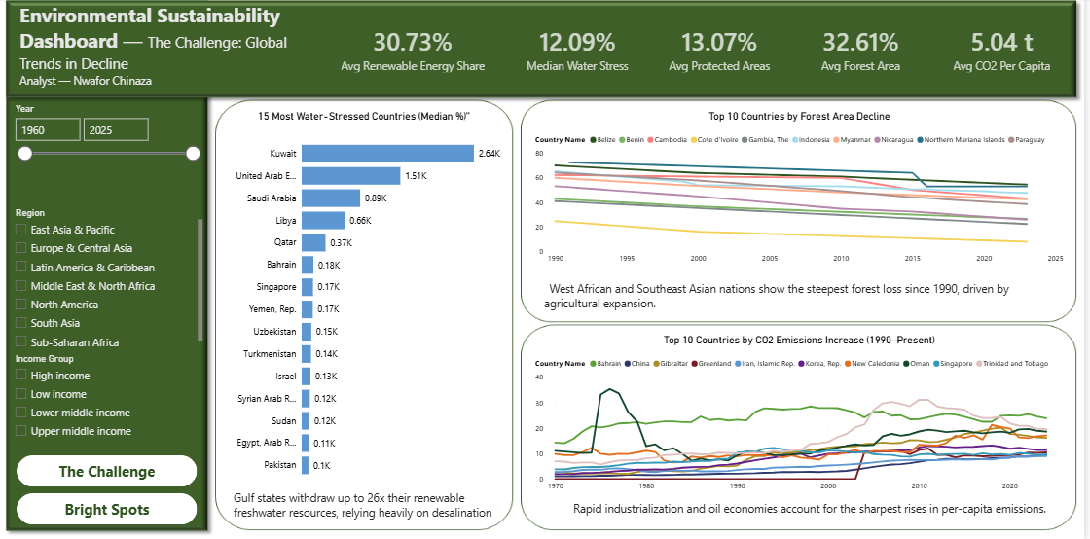
Figure 1. Global snapshot of environmental decline five KPI cards, forest area decline, CO2 emissions increase, and the 15 most water-stressed countries.

Bright Spots
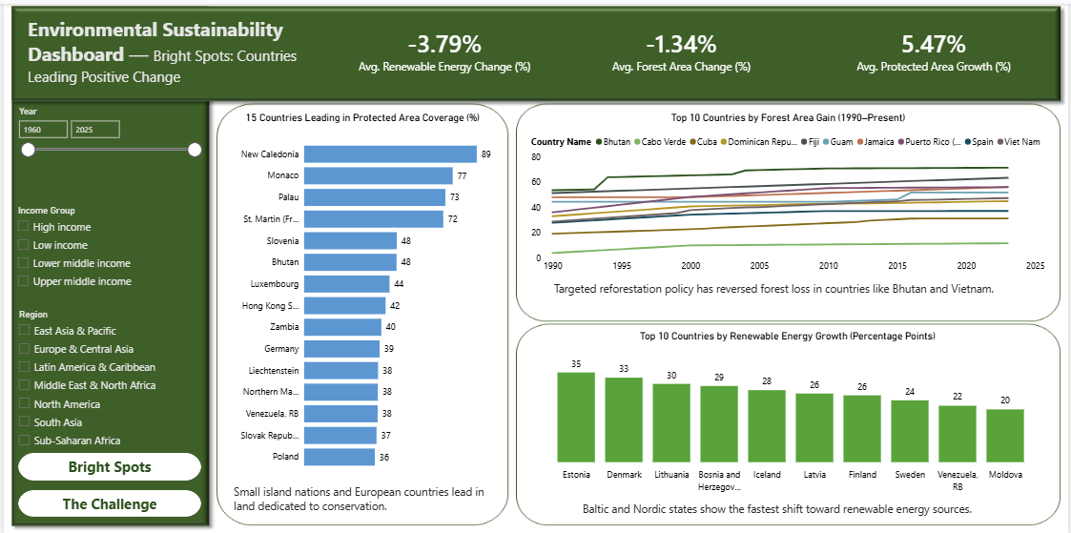
Figure 2. Countries demonstrating measurable positive change renewable energy growth, forest area gain, and leading protected-area coverage.

Live dashboard file and full documentation: [GitHub repository link here]

